**Supplementary Materials**

**Social and metabolic mediation of growth performance in a temperate estuarine fish**

Elizabeth Hoots, Juliet Bao Ngoc Doling, Luis L. Kuchenmüller, Michael R. Skeeles, Timothy D. Clark

School of Life and Environmental Sciences, Deakin University, Geelong, VIC 3216, Australia

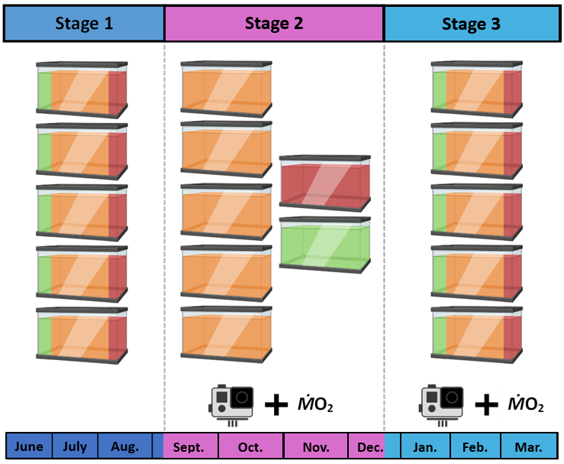

**Figure S1:** Timeline schematic showing tank distributions over the three stages. In Stage 1, five tanks each held seven randomly selected Galaxias maculatus. In Stage 2, the fastest (green) and slowest (red) growing fish identified in Stage 1 were pooled into two new tanks, leaving behind the intermediate-growing (orange) fish in the original five tanks. Pooled fish were then returned to their original tanks in Stage 3. Video recordings of feeding and burst swimming behavior, and metabolic performance measurements (standard, maximum, and routine metabolic rate) were collected in Stages 2 and 3. Camera art from cleanpng.com, fish tank graphics created in biorender.com (2024).

**Table S1:** Body mass, specific growth rate (SGR) and SGR model residuals for initially fast-, intermediate-, and slow-growing *Galaxias maculatus* across all three stages of the study. Note that three intermediate-growing fish were lost over the course of the study, and 5 untagged fish were categorized as intermediate-growers but were not included in the Stage 1 calculations.

|  |  |  |  |  |  |  |  |  |  |  |  |  |
| --- | --- | --- | --- | --- | --- | --- | --- | --- | --- | --- | --- | --- |
|  | **Stage 1** | | | | **Stage 2** | | | | **Stage 3** | | | |
|  | ***n*** | **Mass (g)** | **SGR (% growth*day-1)** | **SGR Residuals**  **(% growth*day-1)** | ***n*** | **Mass (g)** | **SGR (% growth*day-1)** | **SGR Residuals**  **(% growth*day-1)** | ***n*** | **Mass (g)** | **SGR (% growth*day-1)** | **SGR Residuals**  **(% growth*day-1)** |
| **Fast** | *5* | 1.087±0.094 | 1.595±0.118 | 0.313±0.108 | *5* | 5.19±0.513 | 0.103±0.148 | -0.215±0.081 | *5* | 5.748±0.566 | 0.297±0.057 | 0.042±0.058 |
| **Intermediate** | *20* | 1.579±0.607 | 1.007±0.408 | -0.016±0.276 | *24* | 4.08±1.379 | 0.325±0.287 | -0.062±0.166 | *22* | 5.695±2.278 | 0.302±0.205 | 0.114±0.16 |
| **Slow** | *5* | 1.16±0.222 | 0.776±0.194 | -0.012±0.129 | *5* | 2.556±0.808 | 0.04±0.161 | -0.279±0.134 | *5* | 2.71±1.081 | 0.308±0.154 | 0.013±0.09 |
| **Overall** | *30* | 1.427±0.545 | 1.066±0.426 | 0.039±0.264 | *34* | 4.019±1.404 | 0.251±0.278 | -0.116±0.173 | *32* | 5.237±2.22 | 0.302±0.179 | 0.087±0.143 |

**Table S2:** Raw data recorded from video analyses of *Galaxias maculatus* behavior in each tank during Stages 2 and 3, including the number of fish in each tank (Tank Pop.), whether the fish were fed during the recording (“Fed”), the raw number of burst swimming events observed in the recording (“Burst Count”), and the number of times fish were observed feeding during the recording (“Obs. Feeding”).

“Tank ID” is a numerical identifier given to each tank, where 3-7 are the original five tanks which housed intermediate-growers during Stage 2 and all fish during Stages 1 and 3. Tanks 1 and 2 held the fast- and slow-growing fish, respectively, during Stage 2. “Category” indicates the growth phenotype determined for the fish in the tank during Stage 1, where “Mix” is used to identify tanks in Stage 3 with fish of all three growth phenotypes. Bursts observed per minute watched is calculated for each tank on each day in the highlighted column and shown in Fig. 2.

|  |  |  |  |  |  |  |  |  |  |
| --- | --- | --- | --- | --- | --- | --- | --- | --- | --- |
| **Date** | **Stage** | **Tank ID** | **Category** | **Tank Pop.** | **Min. Watched** | **Fed** | **Burst Count** | **Obs. Feeding** | **Bursts Per Minute** |
| 16-Nov-22 | 2 | 1 | Fast | 5 | 16 | Y | 1 | 13 | 0.06 |
| 22-Nov-22 | 2 | 1 | Fast | 5 | 15 | Y | 0 | 6 | 0.00 |
| 26-Nov-22 | 2 | 1 | Fast | 5 | 15 | N | 1 | 6 | 0.07 |
| 2-Dec-22 | 2 | 1 | Fast | 5 | 15 | Y | 2 | 20 | 0.10 |
| 18-Nov-22 | 2 | 2 | Slow | 5 | 12 | Y | 44 | 16 | 3.67 |
| 22-Nov-22 | 2 | 2 | Slow | 5 | 16 | Y | 32 | 11 | 1.97 |
| 26-Nov-22 | 2 | 2 | Slow | 5 | 13 | N | 7 | 1 | 0.54 |
| 2-Dec-22 | 2 | 2 | Slow | 5 | 15 | Y | 28 | 15 | 1.87 |
| 6-Dec-22 | 2 | 4 | Med | 4 | 16 | Y | 11 | 0 | 0.69 |
| 7-Dec-22 | 2 | 4 | Med | 4 | 14 | N | 9 | 5 | 0.64 |
| 17-Dec-22 | 3 | 4 | Mix | 6 | 16 | N | 2 | 6 | 0.13 |
| 19-Dec-22 | 3 | 4 | Mix | 6 | 13 | N | 3 | 0 | 0.23 |
| 20-Dec-22 | 3 | 4 | Mix | 6 | 14 | Y | 4 | 4 | 0.29 |
| 6-Dec-22 | 2 | 3 | Med | 7 | 11 | N | 4 | 65 | 0.36 |
| 7-Dec-22 | 2 | 3 | Med | 7 | 16 | N | 1 | 6 | 0.06 |
| 17-Dec-22 | 3 | 3 | Med | 7 | 16 | N | 0 | 1 | 0.00 |
| 20-Dec-22 | 3 | 3 | Med | 7 | 13 | Y | 4 | 50 | 0.31 |
| 21-Dec-22 | 3 | 3 | Med | 7 | 16 | N | 0 | 6 | 0.00 |
| 8-Dec-22 | 2 | 5 | Med | 4 | 16 | Y | 34 | 0 | 2.13 |
| 10-Dec-22 | 2 | 5 | Med | 4 | 13 | N | 21 | 0 | 1.62 |
| 17-Dec-22 | 3 | 5 | Mix | 6 | 13 | N | 7 | 1 | 0.54 |
| 21-Dec-22 | 3 | 5 | Mix | 6 | 14 | N | 12 | 2 | 0.86 |
| 8-Dec-22 | 2 | 6 | Med | 5 | 15 | Y | 7 | 14 | 0.47 |
| 10-Dec-22 | 2 | 6 | Med | 5 | 14 | N | 7 | 8 | 0.50 |
| 19-Dec-22 | 3 | 6 | Mix | 7 | 10 | N | 13 | 6 | 1.30 |
| 21-Dec-22 | 3 | 6 | Mix | 7 | 16 | N | 21 | 2 | 1.31 |
| 8-Dec-22 | 2 | 7 | Med | 4 | 15 | Y | 8 | 70 | 0.53 |
| 10-Dec-22 | 2 | 7 | Med | 4 | 13 | N | 0 | 1 | 0.00 |
| 19-Dec-22 | 3 | 7 | Mix | 7 | 11 | N | 5 | 4 | 0.45 |
| 20-Dec-22 | 3 | 7 | Mix | 7 | 15 | Y | 12 | 16 | 0.80 |